**ID:** BU_0015

**Summary:** Tooltip contains a colon symbol if there is no information under the doctor's photo

**Description:** The tooltip contains the colon symbol instead of information about the doctor when you hover the mouse over the doctor's image, which doesn’t have any description in the English version of the “Doctors” page.

**Preconditions:**

* User has access to Chrome Browser

**Steps to reproduce:**

1. Open [the main page of the “Oxford Medical” website](https://oxford-med.com.ua/en/).
2. Select ENG language from the dropdown list of the Header.
3. Click on the “Doctors” button in the Navigation menu.
4. Scroll down to the photos of the doctors.

**Actual Result:**

Some of the doctors’ images don’t have the descriptions under them.

**Expected Result:**

All of the doctor’s images have the descriptions under them.

1. Hover the doctor’s image without any description under it.

**Actual Result:**

The tooltip contains only the colon symbol.

**Expected result:**

The tooltip contains information about the doctor.

**Attachments:**

<https://youtu.be/LLXvYrZWsUA>

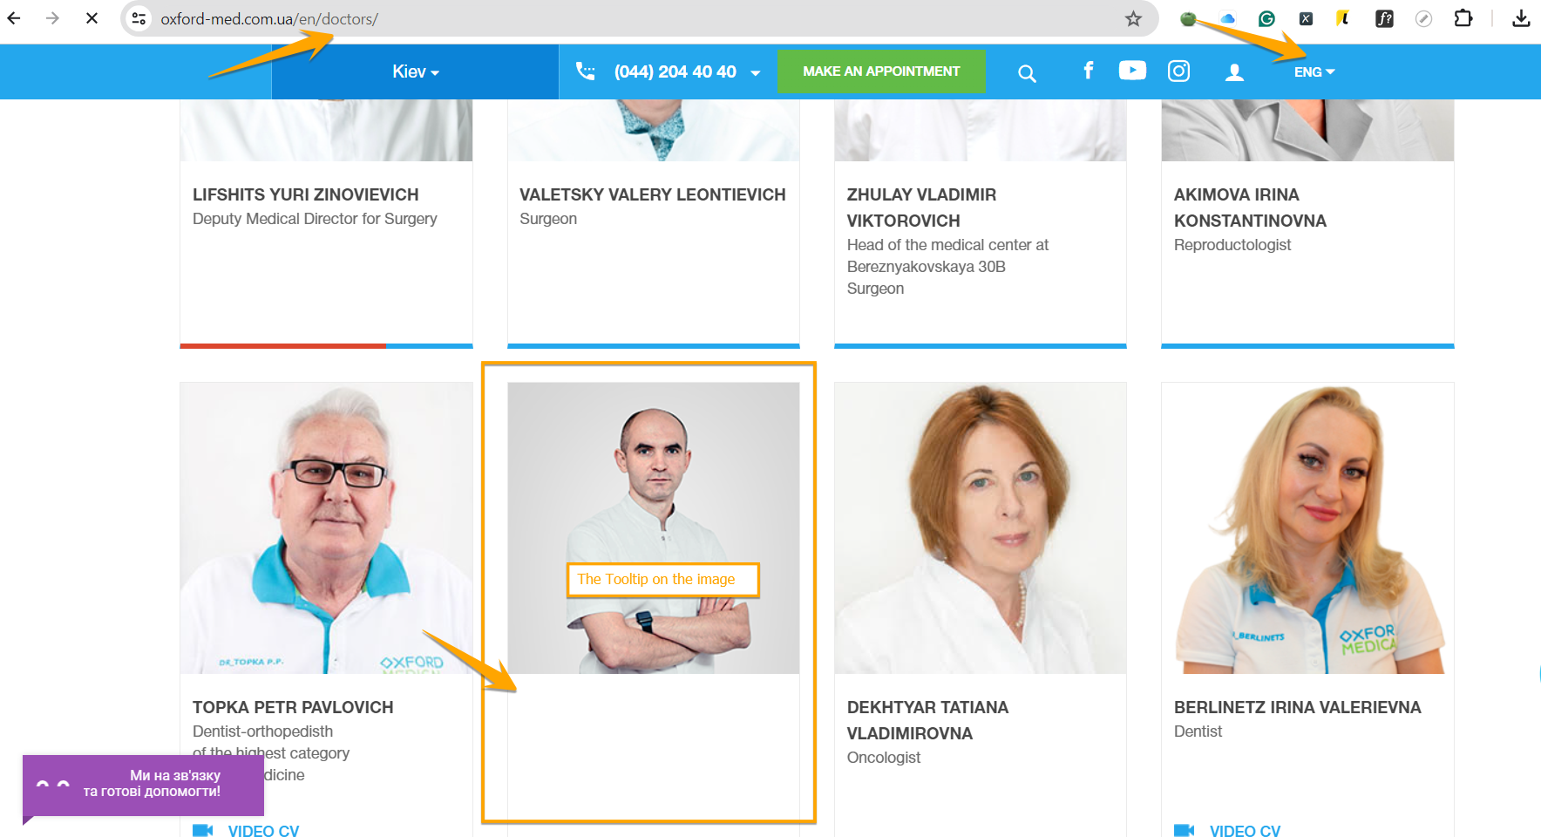

**Priority:** Low

**Severity:** Minor

**Status:** Opened

**Components:** Google Chrome v. 123.0.6312.106; Windows 11, version 23H2

**Reporter:** Viktoriia Khodakivska

**Assignee:** Nadiia Ovsiannikova

**ID:** BU_0016

**Summary:** The texts of contacts and addresses are overlapping in the Footer section

**Description:** The texts with contacts and addresses overlap in the Footer section in the English version of the website.

**Preconditions:**

* User has access to Chrome Browser

**Steps to reproduce:**

1. Open [the main page of the “Oxford Medical” website](https://oxford-med.com.ua/en/).
2. Select ENG language from the dropdown list of the Header.
3. Scroll down to the Contacts in the Footer section.

**Actual Result:**

The texts of contacts and addresses are overlapping.

**Expected Result:**

The texts of contacts and addresses aren’t overlapping.

**Attachments:**

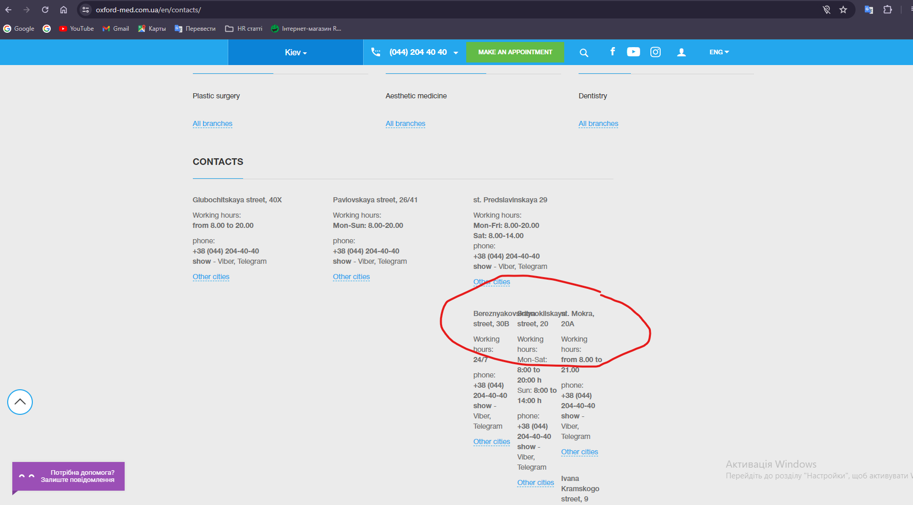

**Priority:** Low

**Severity:** Trivial

**Status:** Opened

**Components:** Google Chrome v. 123.0.6312.106; Windows 11, version 23H2

**Reporter:** Viktoriia Khodakivska

**Assignee:** Nadiia Ovsiannikova

**ID:** BU_0017

**Summary:** The “Name” Input field has no required input conditions

**Description:** The “Name” Input Field has no required input conditions in the “Make an appointment” pop-up, so the user can enter any number of characters from one to infinity.

**Preconditions:**

* User has access to Chrome Browser

**Steps to reproduce:**

1. Open [the main page of the “Oxford Medical” website](https://oxford-med.com.ua/en/).
2. Scroll down the page to the “Make an appointment” pop-up.
3. Enter any kind of symbol in the “Name” Input Field.
4. Enter more symbols, including characters, numbers, punctuation marks etc.

**Actual Result:**

The “Name” Input Field turns green.

**Expected Result:**

The “Name” Input Field turns red; the tooltip to use right symbols appears under the Input Field.

**Attachments:**

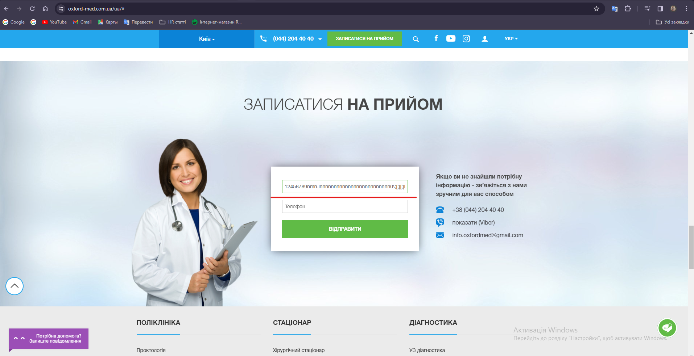

**Priority:** High

**Severity:** Minor

**Status:** Opened

**Components:** Google Chrome v. 123.0.6312.106; Windows 11, version 23H2

**Reporter:** Viktoriia Khodakivska

**Assignee:** Nadiia Ovsiannikova

**ID:** BU_0018

**Summary:**The name of one of the special offers is cropped and doesn’t fit completely into the tile

**Description:**The name of one of the special offers is cropped and doesn't fit completely into the tile in the English version of the website.

**Preconditions:**

* User has access to Chrome Browser

**Steps to reproduce:**

1. Open [the main page of the “Oxford Medical” website](https://oxford-med.com.ua/en/).
2. Select ENG language from the dropdown list of the Header.
3. Scroll down to the “Current Special Offers” section.
4. Pay attention to the blue tile with a special offer named “Breast Physician Consultation + Ultrasound of Mammary Gland for only 980 UAH”.

**Actual Result:**

The name of the offer is cropped and doesn’t fit in the tile.

**Expected Result:**

The name of the offer fits perfectly in the tile.

**Attachments:**

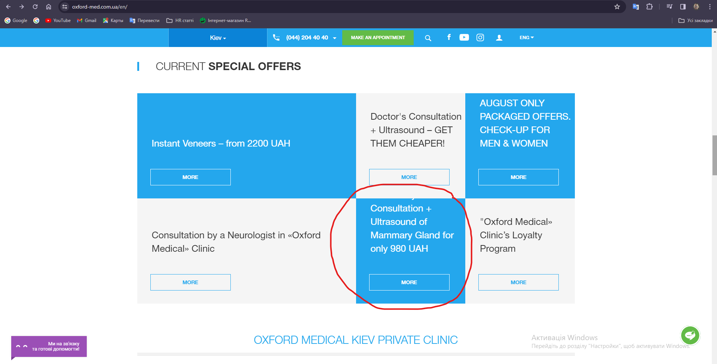

**Priority:** Low

**Severity:** Trivial

**Status:** Opened

**Components:** Google Chrome v. 123.0.6312.106; Windows 11, version 23H2

**Reporter:** Viktoriia Khodakivska

**Assignee:** Nadiia Ovsiannikova

**ID:** BU_0019

**Summary:**One of the images in the Carousel is overlapping the Carousel’s slider

**Description:** Third image in the Carousel is overlapping the Carousel’s slider and the user can’t see it on the main page of the website.

**Preconditions:**

* User has access to Chrome Browser

**Steps to reproduce:**

1. Open [the main page of the “Oxford Medical” website](https://oxford-med.com.ua/en/).
2. Pay attention to the Carousel’s images.

**Actual Result:**

Third image in the Carousel is overlapping the Carousel’s slider.

**Expected Result:**

None of the images in the Carousel is overlapping with the Carousel’s slider.

**Attachments:**

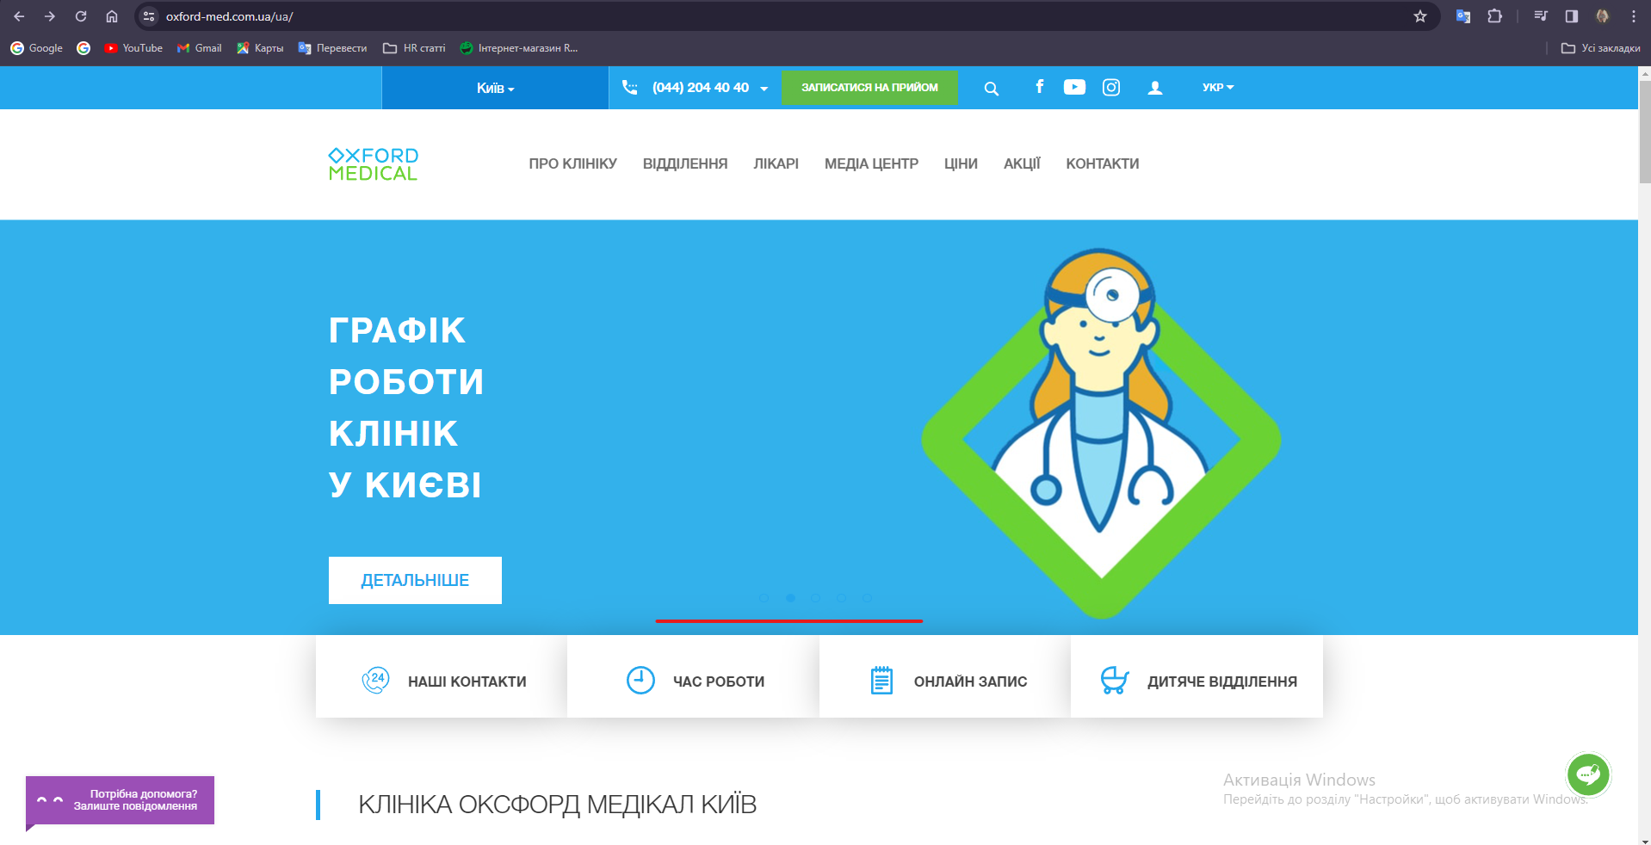

**Priority:** Low

**Severity:** Trivial

**Status:** Opened

**Components:** Google Chrome v. 123.0.6312.106; Windows 11, version 23H2

**Reporter:** Viktoriia Khodakivska

**Assignee:** Nadiia Ovsiannikova